High Blood Pressure

This leaflet explains what impacts having high blood pressure may have

on your health, and what you can do to address it.

What is blood pressure?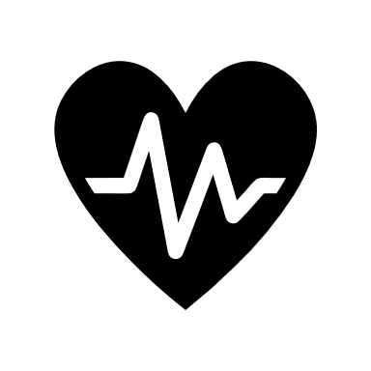

Blood pressure is a measure of the pressure your heart creates. As it pumps, it contracts (systolic) and relaxes (diastolic). In adults, systolic pressure is about 120 and diastolic pressure 70, written as 120/70. However, just as there is no ‘normal’ height, there is no ‘normal’ blood pressure.

So, what is high blood pressure?

High blood pressure is when a reading is higher than considered ‘normal’ for you. A reading of about 140/90 or over is often considered to be high.

Who is at risk of having high blood pressure?

10-20% of UK adults have high blood pressure. Men are more at risk, and it is more common in older adults.

What causes high blood pressure?

Blood pressure rises when there is higher resistance to the heart pumping. Often, there is no obvious cause. This is called essential hypertension. This seems to run in some families. In less than 1 in 20, there is an underlying cause. Temporary high blood pressure can occur in pregnancy.

Is high blood pressure dangerous?

High blood pressure itself is not dangerous. The risk of having a heart attack or stroke in the future may be higher. As an example:

In a middle-aged man, each rise of 10mm pressure increases his risk of a heart attack or stroke by 20%.

What are the symptoms?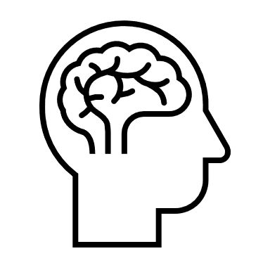

People with high blood pressure normally feel perfectly well. Very high blood pressure may cause giddiness, breathlessness, visual problems, or headaches.

What can help?

Lifestyle change is important. This may be enough to keep your blood pressure at a normal level. Your doctor may also consider medicine. You may need to try different sorts and doses before you get the right medicine. They can include:

* Water tablets (diuretics) e.g. Indapamide – increases the amount of salt that your kidneys remove.
* Beta-blockers e.g. Bisoprolol – makes the heart beat less strongly. Can cause tiredness. Often not suitable for asthmatics.
* ACE inhibitors e.g. Ramipril– relaxes the blood vessels. Side effects are rare with the occasional dry cough. A kidney blood test is important.
* Calcium antagonists e.g. Amlodipine – relaxes the blood vessels. Side effects can include swollen ankles.
* Alpha-blockers e.g. Doxazosin – relaxes blood vessels. They may cause a stuffy nose.

What can you do?

There are areas in which you can make changes, in order to try and lower your blood pressure. These are known as lifestyle changes, and should include:

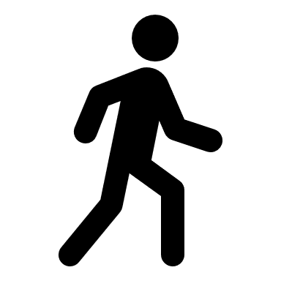

* Manage your weight.
* Eat less salt – salt influences your blood pressure.
* Eat more potassium – found in fresh fruit and vegetables.
* Take more exercise – try to have a brisk 20-minute walk each day.
* 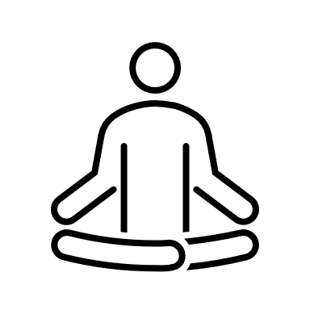Reduce the stress in your life. Stress does not cause high blood pressure but can make it worse.
* Stop smoking. Advice and support available from your GP surgery.
* Reduce your alcohol intake. Less than 14 units per week, with a few alcohol-free days.

Finally

We hope you have found this information helpful. Please ask us about anything you don't understand.